BROADWAY DANCE BD2 - S19
Mrs. Grupe/ kgrupe@iwacademy.org/ www.iwadance.weebly.com

Essential Question:
- If practice makes perfect, what makes perfect practice?

LAP 1

Class Meetings: January 4, B day – January 24, E day

Material needed for LAP:
Dress out clothes, jazz shoes and willingness to participate.

LAP Objectives:
- Recognize proper posture and body alignment
- Recognize and translate basic dance movements and terms
- Execute a number of exercises that develop skill
- Identify elements of “performance quality”
- Showcase confidence while correctly performing a choreographed routine in front of a classroom audience

Homework:
- Get jazz shoes – all students must have their own pair of jazz shoes by January 18 for dress code
- Review and practice movement skills and combinations
- Come to Open Lab for individual practice if necessary

Open Lab Activities:
Students should use Open Lab time to ask questions, obtain one-on-one instruction and practice movement exercises in order to increase skills and build confidence. Make-up classes are completed in Open Lab.
Formative Assessments –
*Class Participation – 10 points max each class meeting/ recorded as 50 points possible per cycle
*Class activities
*Skills Checks

Summative Assessment –
Performance Test – students will perform in small groups. Performance will be in class on January 24, E day
* remember to wear all black or dark colored clothing

*This LAP may be changed at the instructor’s discretion. Classroom announcements and Weebly updates will be made in the event of any changes. It is the student’s responsibility to remain aware of changes.

Class Meetings:
DAY - DATE -LETTER | IN-CLASS ACTIVITY: | ASSIGNMENT:
1 – January 4 – B day | - Assign lockers and locks begin learning movement skills | Begin using your PE locker,  Obtain jazz shoes
2 – January 8 – D day | - Review movement from last class  - Continue to learn new skills
3 – January 9 – E day | - Review movement from last class  - Continue to learn new skills | Practice skills
4 – January 11 – G day | - Skills exercises & movement combo | Review vocabulary & practice Combo
5 – January 16 – K day | - ALL STUDENTS MUST HAVE THEIR OWN JAZZ SHOES BY THIS CLASS  - Vocabulary activity  - Group practice | Practice Combo
6 – January 18 – B day | - Assign performance groups  - Practice and cleaning
7 – January 23 – D day | - Final review for Performance Test | Practice Combo for PERFORMANCE TEST NEXT CLASS
8 – January 24 – E day | - LAP 1 PERFORMANCE TEST  - Students will perform in class, 1 group at a time, remember all black

LAP 1 Movement Vocabulary:

- Ball – The pad beneath the toes on the bottom of the foot

- Ball change – a transfer of weight to the ball of the free foot then back to the supporting foot

- Chainés – (a chain of turns) - can be done in plié or relevé

- Chassé – (chased) one foot chases the other out of its position

- Dig - To strike the ball of the foot on the ground, close to the supporting foot, getting it ready for use

- Grapevine – a weaving pattern of the feet: step open, cross back, step open again

- Jazz Square – also called box-step, a pattern of steps creating the shape of the corners of a square

- Parallel – refers to the position of the hips/legs/feet where the toes/knees/thighs are pointed straight forward and the heels pointed straight back. There is equal distance between the legs/feet, which will never touch.

- Pivot turn – up to a ½ rotation pivoting around the ball of the supporting foot which does not leave the floor

- Plié – bending

- Port de bra – (carriage of the arms) in a range of movements and positions based from classical ballet

- Relevé – (raised) to raise the body, lifting the heels off the floor

- Sauté – jumping

- Sickle Foot –inversion of the ankle, improper technique of ankle for pointed foot

- Turnout – refers to the outward rotation of the hips, legs and feet

Positions of the feet and arms:

First Position Second Position Fifth Position
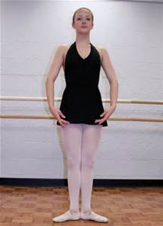 - or - 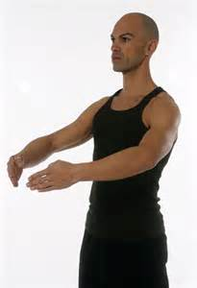 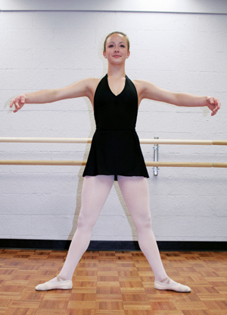 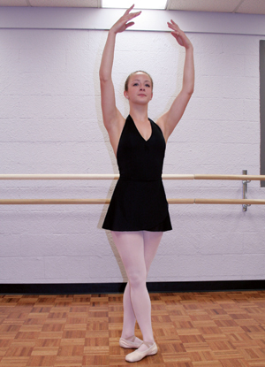

Proper Foot Technique:

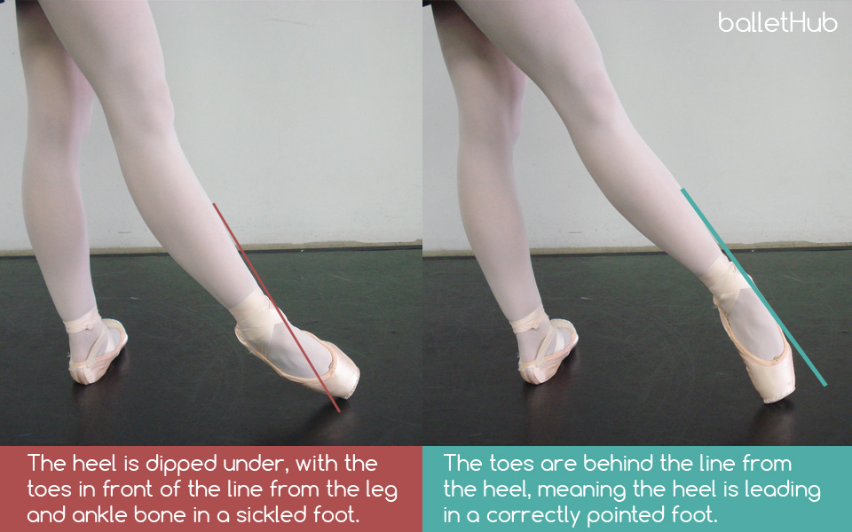

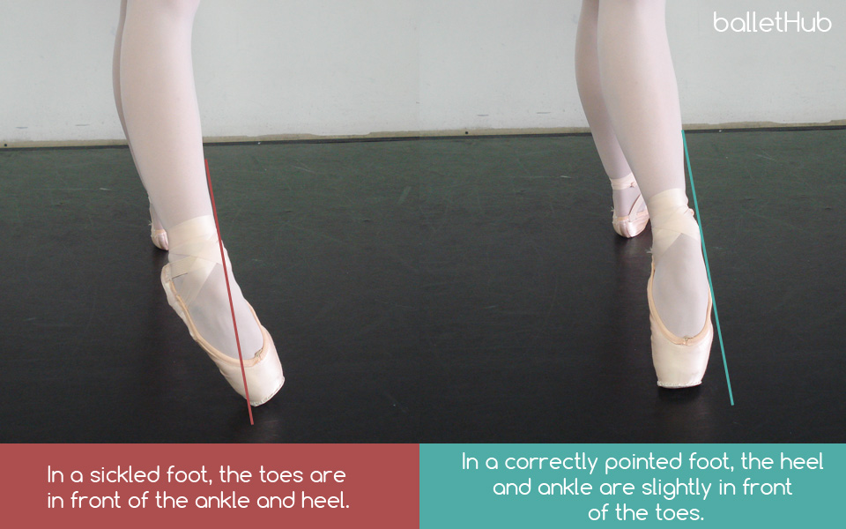

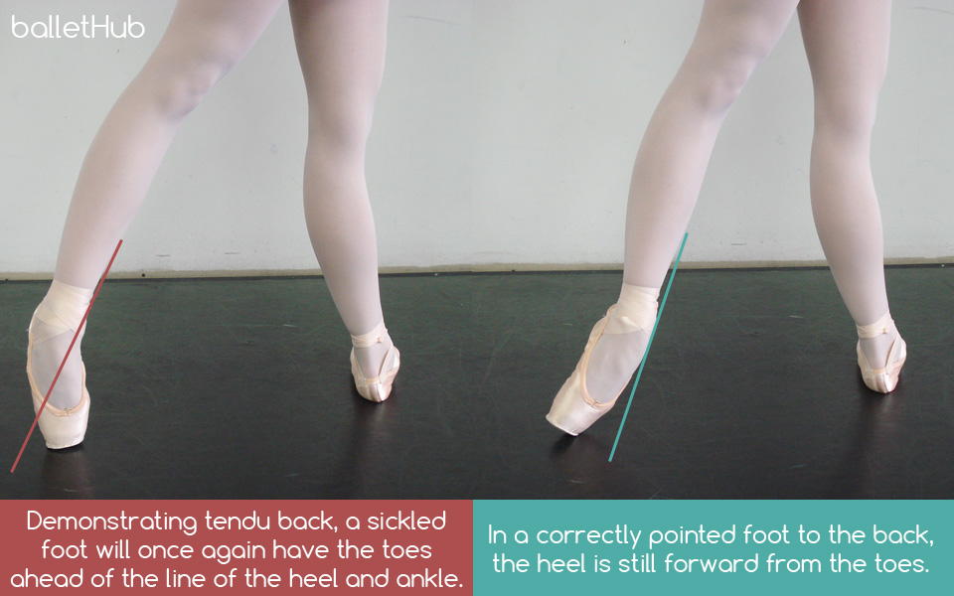

Posture Diagram:

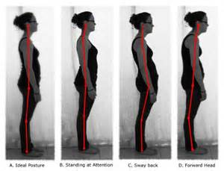

Plié Technique:

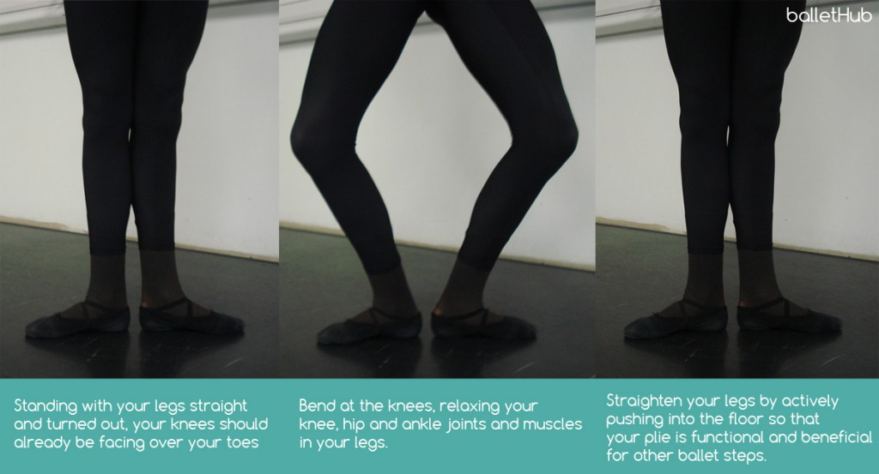

Stage Directions:
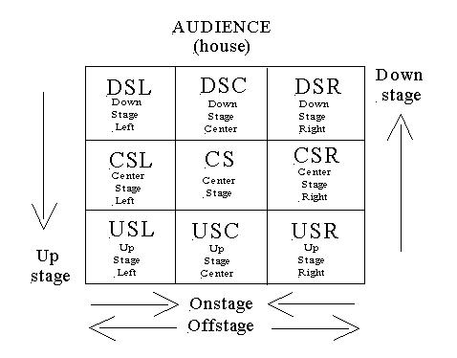

(LAP 2 Preview: Elements of Dance)

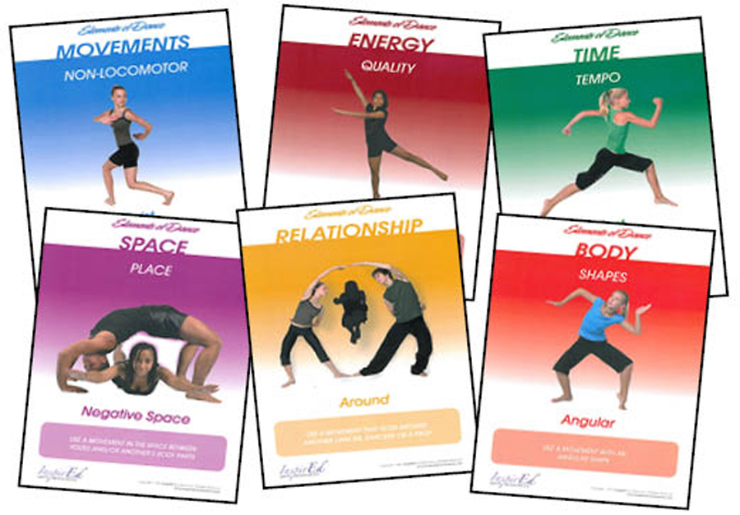

*MOVEMENT (ACTION)
*RELATIONSHIP
*BODY
*ENERGY
*SPACE
*TIME

